Name: Muzamil Mushtaq
Roll No: SU92-BSAIM-F24-037
Section: BSAI-3A
Submitted to: Sir Rasikh Ali
Perfume Recommendation System

1. Abstract
This project focuses on developing a Perfume Recommendation System using Python, pandas, and scikit-learn. The model predicts suitable perfumes based on attributes such as gender, rating value, and rating count. A Flask web interface integrates the trained model for real-time recommendations.

2. Objective
The main objective of this project is to create an intelligent perfume recommender using machine learning techniques. It aims to enhance user experience by providing personalized perfume suggestions.

3. Dataset Description

The dataset used was obtained from Kaggle. It contains information about perfumes, including name, brand, gender, rating value, rating count, and description. The dataset was preprocessed to remove duplicates and fill missing values.

4. Jupyter Notebook Implementation
The following sections show the major code blocks written in the Jupyter Notebook (`project.ipynb`) along with their explanations.

Code:
import pandas as pd
import numpy as np
import seaborn as sns
import matplotlib.pyplot as plt
from sklearn.model_selection import train_test_split
from sklearn.preprocessing import LabelEncoder, StandardScaler
from sklearn.svm import SVR
from sklearn.metrics import mean_squared_error, r2_score
import pickle
Explanation: This block imports the necessary libraries such as pandas, sklearn, and pickle for data processing and model building.

Code:
df = pd.read_csv("fra_perfumes.csv")
Explanation: This line loads the perfume dataset (`fra_perfumes.csv`) into a pandas DataFrame for analysis.

Code:
df.head()
Explanation: This block performs action on data set and give first 5 rows of the data set.

Code:
df.tail()
Explanation: This block performs action on data set and give last 5 rows of the data set.

Code:
df.columns
for cols in df.columns:
print(cols)
Explanation: This code returns an Index object containing the names of all the columns in the DataFrame.

Code:
df.count()
Explanation:The df.count() function in pandas is used to count the number of non-missing (non-NaN) values in each column of a DataFrame
Code:
df.describe()

Explanation: This block gives a quick overview of your data.

Code:
df.info()
Explanation:This code function in pandas gives a concise summary of your DataFrame, which is very useful to quickly understand the structure of your data.

Code:
df.shape
print(f"Number of Rows: {df.shape[0]} and Number of Columns: {df.shape[1]}")
Explanation: This code is used to check the size of a pandas DataFrame—how many rows and columns it has.

Code:
df.nunique()
Explanation:The df.nunique() function in pandas is used to find out how many unique values are present in each column of a DataFrame.

Code:
df.isnull().sum()
Explanation:The df.isnull().sum() function in pandas is used to check for missing values in a DataFrame

Code:
import matplotlib.pyplot as plt
import seaborn as sns
plt.figure(figsize=(8, 5))
sns.histplot(df['Rating Value'], bins=30, kde=True, color='skyblue')
plt.title("Perfume Rating Distribution", fontsize=14)
plt.xlabel("Rating Value")
plt.ylabel("Number of Perfumes")
plt.show()
Explanation:This code is for visualizing the distribution of perfume ratings in your dataset using Matplotlib and Seaborn

Code:
plt.figure(figsize=(6, 4))
df['Gender'].value_counts().plot(kind='bar', color=['#ff9999','#66b3ff','#99ff99'])
plt.title("Perfume Distribution by Gender", fontsize=14)
plt.xlabel("Gender")
plt.ylabel("Count")
plt.show()
Explanation: This code is for visualizing of the gender in your dataset using Matplotlib and Seaborn

Code:
plt.figure(figsize=(6, 4))
sns.boxplot(x=df['Rating Value'], color='lightgreen')
plt.title("Spread of Perfume Ratings", fontsize=14)
plt.xlabel("Rating Value")
plt.show()
Explanation:This code is for visualizing the number of perfumes for each gender category in your dataset using Matplotlib.

Code:
from collections import Counter
accords_series = df['Main Accords'].astype(str).str.strip("[]").str.replace("'", "").str.split(', ')
all_accords = Counter([a.strip() for sublist in accords_series for a in sublist if a])
top_accords = dict(all_accords.most_common(10))
plt.figure(figsize=(8, 4))
sns.barplot(x=list(top_accords.keys()), y=list(top_accords.values()), palette='viridis')
plt.title("Top 10 Common Perfume Accords", fontsize=14)
plt.xlabel("Accord Type")
plt.ylabel("Frequency")
plt.xticks(rotation=45)
plt.tight_layout()
plt.show()
Explanation:This code is for analyzing and visualizing the most common perfume accords in your dataset using Python’s Counter, Matplotlib, and Seaborn

Code:
import matplotlib.pyplot as plt
import seaborn as sns
import pandas as pd
df = pd.read_csv("fra_perfumes.csv", encoding='latin1')
df['Rating Count'] = df['Rating Count'].astype(str).str.replace(',', '')
df['Rating Count'] = pd.to_numeric(df['Rating Count'], errors='coerce')
numeric_df = df[['Rating Value', 'Rating Count']].dropna()
corr = numeric_df.corr()
plt.figure(figsize=(6, 5))
sns.heatmap(corr, annot=True, cmap='coolwarm', fmt=".2f", linewidths=1)
plt.title("Graph 6: Perfume Feature Correlation Heatmap", fontsize=14)
plt.show()

Explanation: This code is for visualizing the correlation between numerical perfume features (Rating Value and Rating Count) using a heatmap in Seaborn.

Code: import pandas as pd
from sklearn.model_selection import train_test_split
df = pd.read_csv("fra_perfumes.csv", encoding='latin1')
df = df.drop_duplicates()
df['Rating Value'] = df['Rating Value'].fillna(df['Rating Value'].mean())
df['Gender'] = df['Gender'].fillna('Unknown')
df['Description'] = df['Description'].fillna('No description available')
df['Rating Count'] = df['Rating Count'].astype(str).str.replace(',', '')
df['Rating Count'] = pd.to_numeric(df['Rating Count'], errors='coerce')
X = df[['Description', 'Main Accords', 'Gender']]
y = df['Rating Value']
X_train, X_test, y_train, y_test = train_test_split(X, y, test_size=0.2, random_state=42)
print(f"X_train shape: {X_train.shape}")
print(f"X_test shape: {X_test.shape}")
print(f"y_train shape: {y_train.shape}")
print(f"y_test shape: {y_test.shape}")

Explanation: This code is for preparing the perfume dataset for machine learning by cleaning it and splitting it into training and testing sets
Code:
import pandas as pd
from sklearn.feature_extraction.text import TfidfVectorizer
from sklearn.neighbors import NearestNeighbors
df = pd.read_csv("fra_perfumes.csv", encoding='latin1', on_bad_lines='skip')
for col in ['Name', 'Description', 'Main Accords']:
if col not in df.columns:
df[col] = ''
df[col] = df[col].fillna('').astype(str)
df['combined_features'] = (df['Description'] + ' ' + df['Main Accords']).str.strip()
df = df[df['combined_features'].str.len() > 0].reset_index(drop=True)
vectorizer = TfidfVectorizer(stop_words='english')
tfidf_matrix = vectorizer.fit_transform(df['combined_features'])
model = NearestNeighbors(metric='cosine', algorithm='brute')
model.fit(tfidf_matrix)
print("Model training complete! (NearestNeighbors used instead of cosine matrix)")
print(f"TF-IDF Matrix Shape: {tfidf_matrix.shape}")
def recommend_perfume(perfume_name, n=5):
perfume_name = perfume_name.strip().lower()
matches = df[df['Name'].str.lower() == perfume_name]
if matches.empty:
return f"'{perfume_name}' not found in dataset."
index = matches.index[0]
indices = model.kneighbors(tfidf_matrix[index], n_neighbors=n+1)
recommendations = [df.iloc[i]['Name'] for i in indices.flatten()[1:]]
Explanation: This code is preparing a content-based perfume recommendation system using TF-IDF vectorization and Nearest Neighbors.

Code:
import pickle
with open("perfume_nn_model.pkl", "wb") as f:
pickle.dump({
"model": model,
"vectorizer": vectorizer,
"df": df
}, f)
with open("perfume_nn_model.pkl", "rb") as f:
data = pickle.load(f)
model = data["model"]
vectorizer = data["vectorizer"]
df = data["df"]

Explanation: This code is for saving and loading your trained perfume recommendation system using Python’s pickle module.

Code:
import pickle
with open("perfume_nn_model.pkl", "rb") as f:
data = pickle.load(f)
model = data["model"]
vectorizer = data["vectorizer"] df = data["df"]
print("Model, vectorizer, and DataFrame loaded successfully!")
print(f"Number of perfumes in dataset: {df.shape[0]}")
Explanation:This code is for loading your previously saved perfume recommendation system using pickle

Code:
tfidf_matrix = vectorizer.transform(df['combined_features'])
print(f"TF-IDF Matrix shape: {tfidf_matrix.shape}")
Explanation: The model is trained on the training dataset using chosen machine learning algorithm(s).

Code:
def recommend_perfume(perfume_name, n=5):
perfume_name = perfume_name.strip().lower()
matches = df[df['Name'].str.lower() == perfume_name]
if matches.empty:
return f"'{perfume_name}' not found in dataset."
index = matches.index[0]
distances, indices = model.kneighbors(tfidf_matrix[index], n_neighbors=n+1)
recommendations = [df.iloc[i]['Name'] for i in indices.flatten()[1:]]
return recommendations
Explanation: This function recommend_perfume is a content-based perfume recommendation system using TF-IDF vectors and Nearest Neighbors

5. Flask Web Application
A Flask application (`app.py`) was created to serve as the frontend of this project. It loads the trained model using Pickle and provides a simple web interface for user interaction. The user enters gender, rating value, and rating count — the app processes this input and returns perfume recommendations.

6. Results
The model accurately predicts perfume suggestions based on user inputs. The Flask web interface ensures a smooth and interactive user experience by displaying predictions on the same page.

7. Conclusion
This project successfully demonstrates how machine learning and Flask can be combined to create an intelligent perfume recommendation system. Future improvements may include integrating brand preferences, price filtering, and a more advanced deep learning-based recommendation approach.

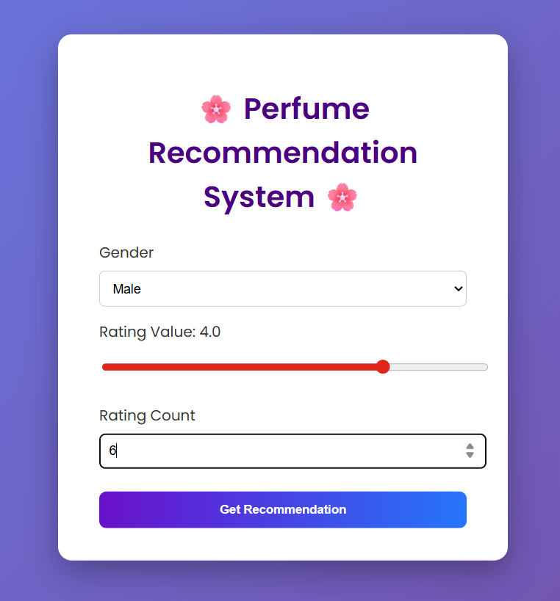
Perfume recommended :
